Preparing the Way: Teaching ELs in the PreK-12 Classroom

Applying Literacy Strategies for ELs in the Classroom

Chapter 7
V. Wright

Probable Passage
This strategy helps students develop an awareness of story structure, improve comprehension, and increase vocabulary development.
Directions:

1. The teacher prepares lesson by selecting a story and a list of vocabulary words that contain important

concepts from the story. They should also represent categories in the story frame matrix.

- The vocabulary words are introduced to the students. It is important that the students are able to pronounce the words and have some understanding of them.

- Using the story frame matrix, the students place the vocabulary words where they feel they most likely belong. The teacher accepts all predictions.

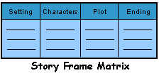

- The students complete the probable passage, which is a paragraph with story structure elements (setting, characters, problem, and solution) deleted. Students use the vocabulary words categorized in step 3 to complete the passage. All predictions are accepted.

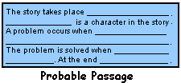

- The students read the selected story to determine if their predictions for both the story frame matrix, and probable passage were correct.

Reference:
Wood, K. D. (1984). Probable passages: A writing strategy. The Reading Teacher, 37(5), 496-499.

